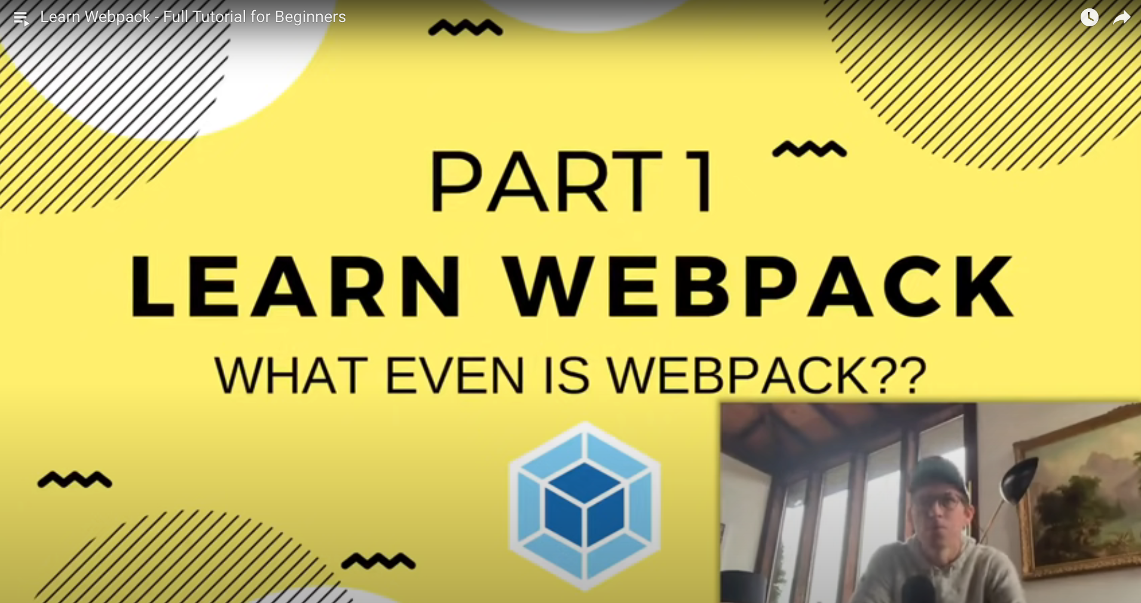

[Learn Webpack - Full Tutorial for](https://www.youtube.com/watch?v=MpGLUVbqoYQ&list=WL&index=3&t=2341s)

[Colt Steele's YouTube channel](https://www.youtube.com/channel/UCrqAGUPPMOdo0jfQ6grikZw)

⭐️ Course Contents ⭐️

⌨️ (0:00:00) What Even Is Webpack??

⌨️ (0:08:12) Installing and Running Webpack and Webpack-CLI

⌨️ (0:22:18) Imports, Exports, & Webpack Modules

⌨️ (0:29:58) Configuring Webpack

⌨️ (0:38:57) Loaders, CSS, & SASS

⌨️ (0:53:55) Cache Busting and Plugins

⌨️ (1:07:13) Splitting Dev & Production

⌨️ (1:17:13) Html-loader, File-loader, & Clean-webpack

⌨️ (1:28:17) Multiple Entrypoints & Vendor.js

⌨️ (1:34:45) Extract CSS & Minify HTML/CSS/JS

1) Initial app code, no webpack